**GCP Project**

**If you are using ubuntu**

**apt-get update**

**apt-get install apache2 -y**

**Task -2 Deploy Compute Engine for Web Servers**

**Set autoscaling 10%**

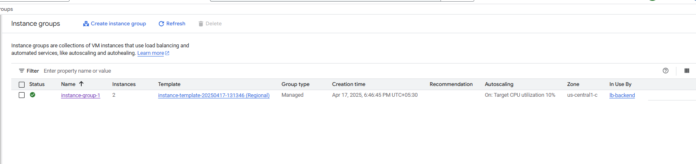

**Vm instance with autoscaling**

**Configure lb backend**

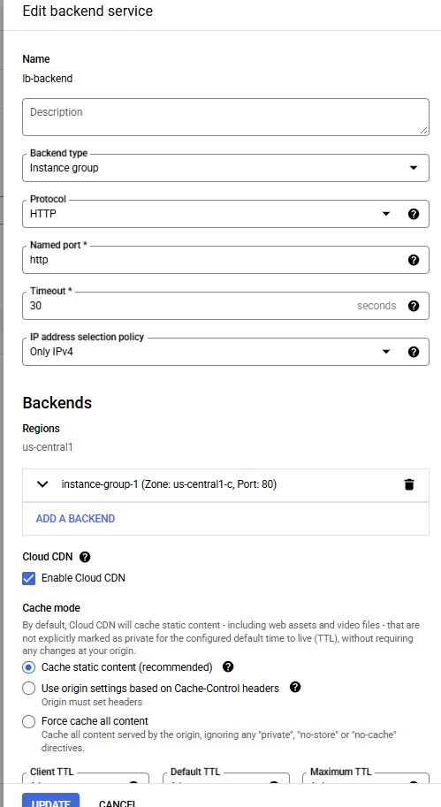

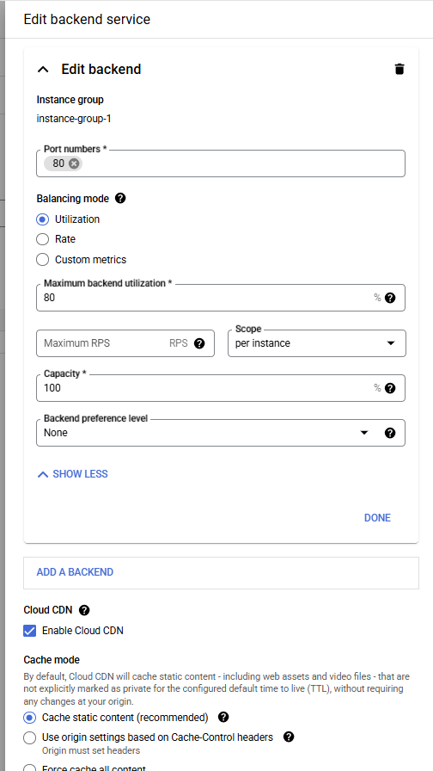

**Creating Health check in load balancer**

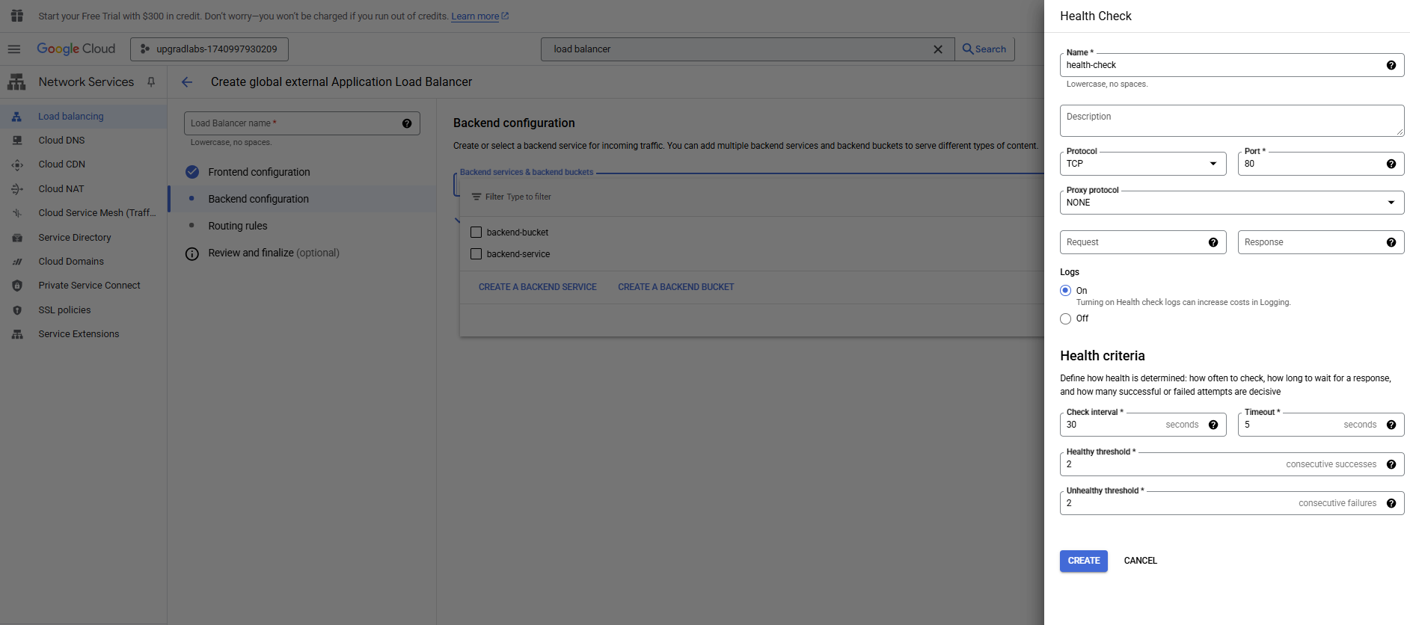

Load balancer

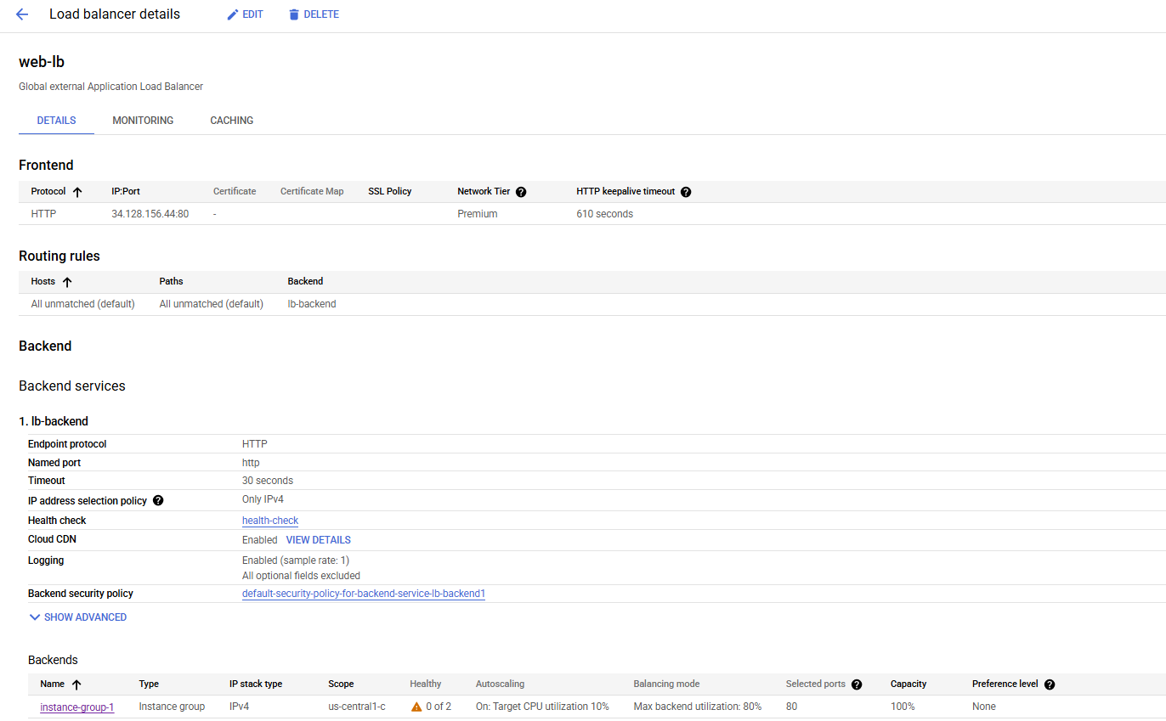

**Deploy Serverless Functions (Cloud Run & Cloud Functions)**

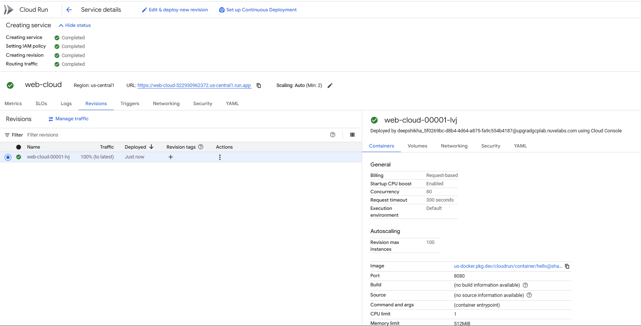

**Create Function, choose a trigger (HTTP, Pub/Sub, etc.), and deploy**

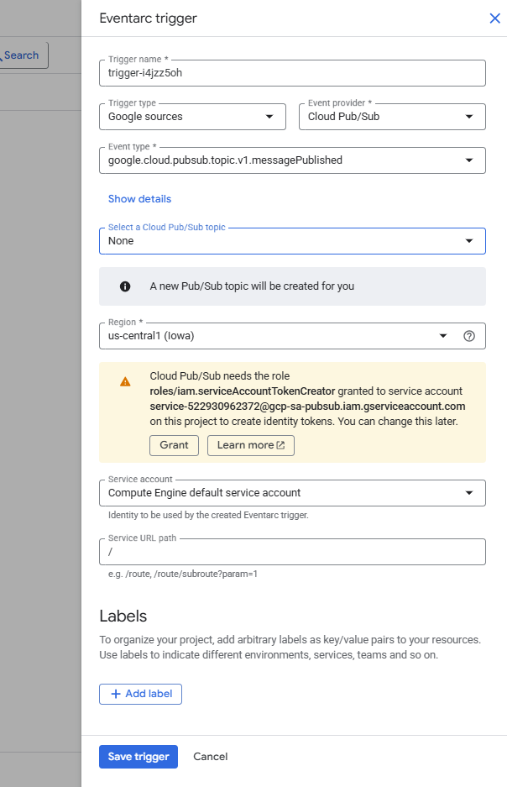

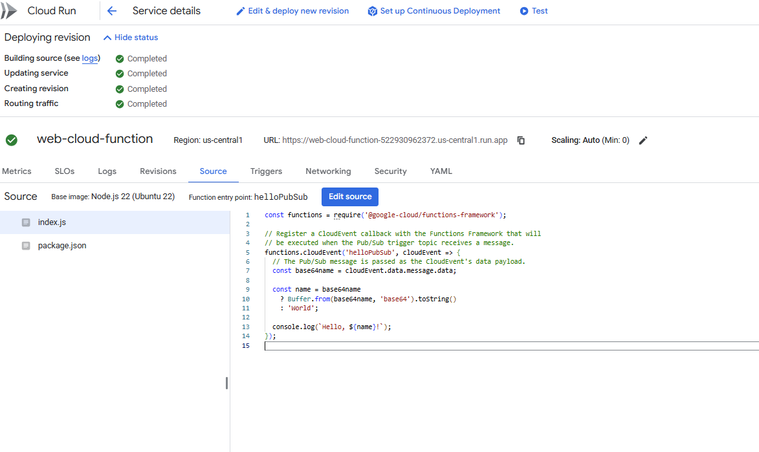cloud run url run in browser



**Task 3 -** **Use Cloud Spanner for global-scale, high-traffic apps**

Create spanner instance

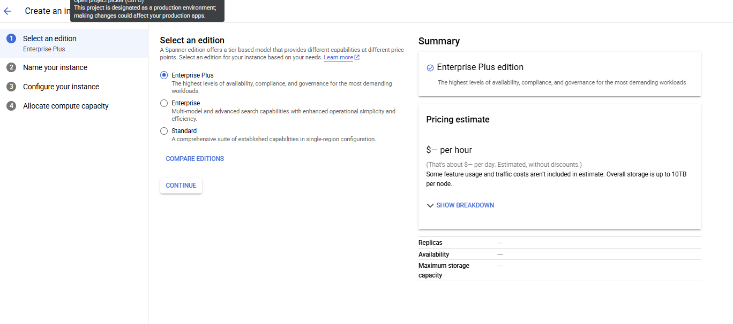

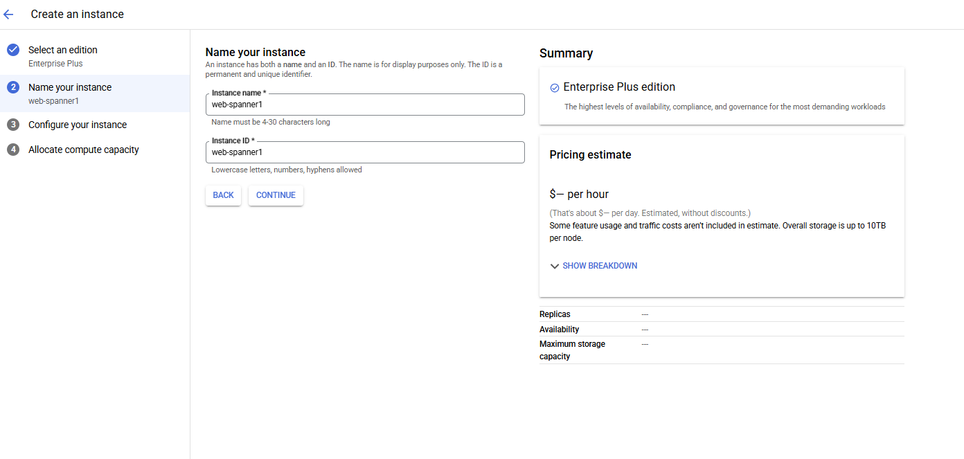Configure instance

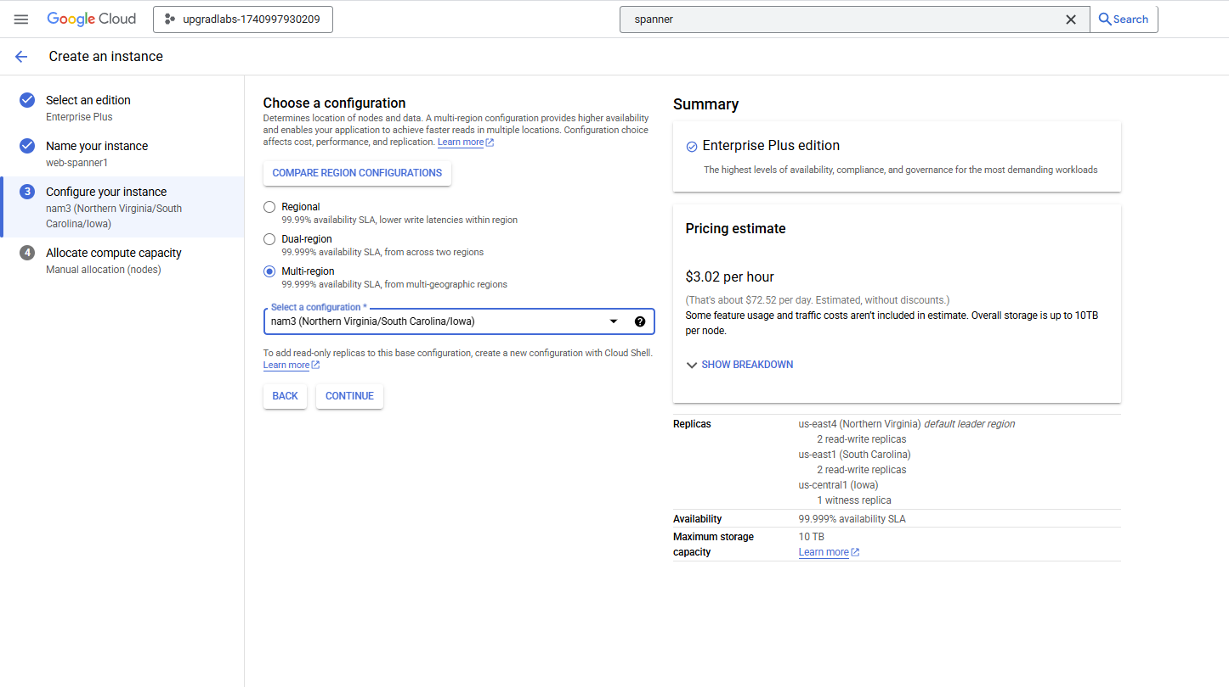Automate compute capacity

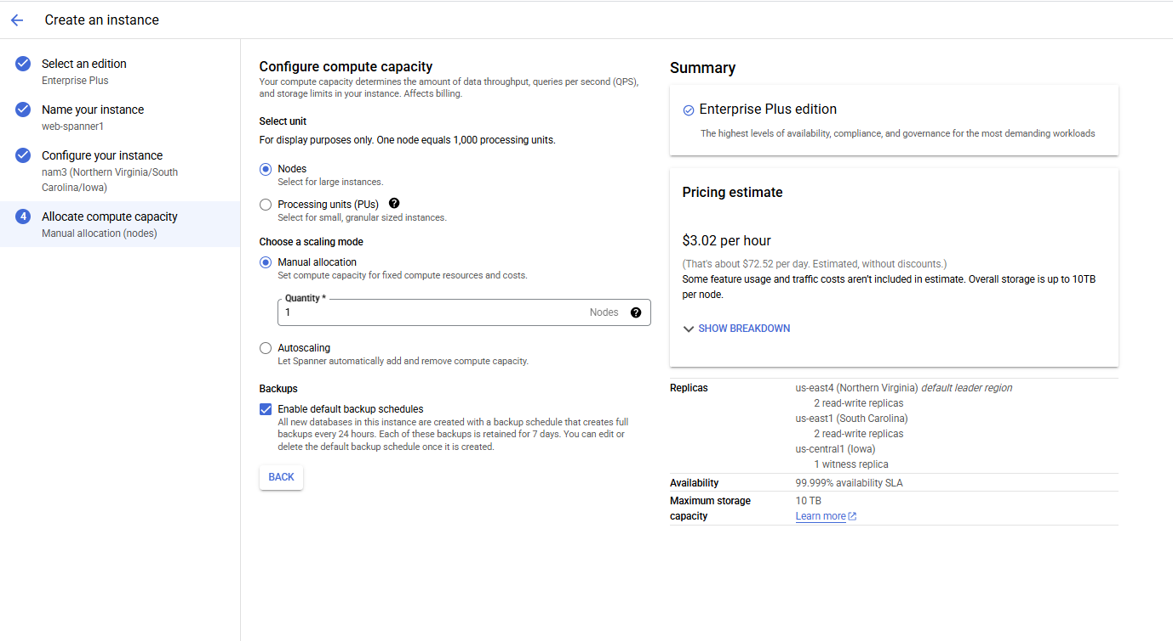Create Database

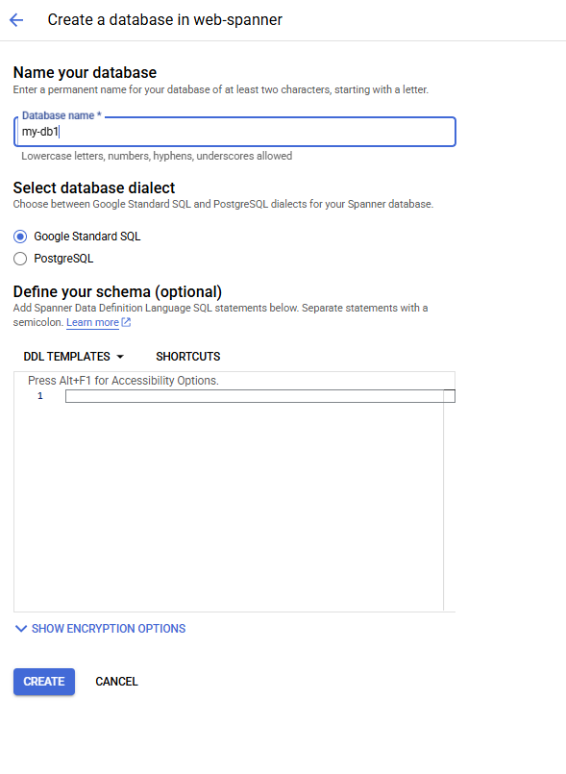

Web Spanner

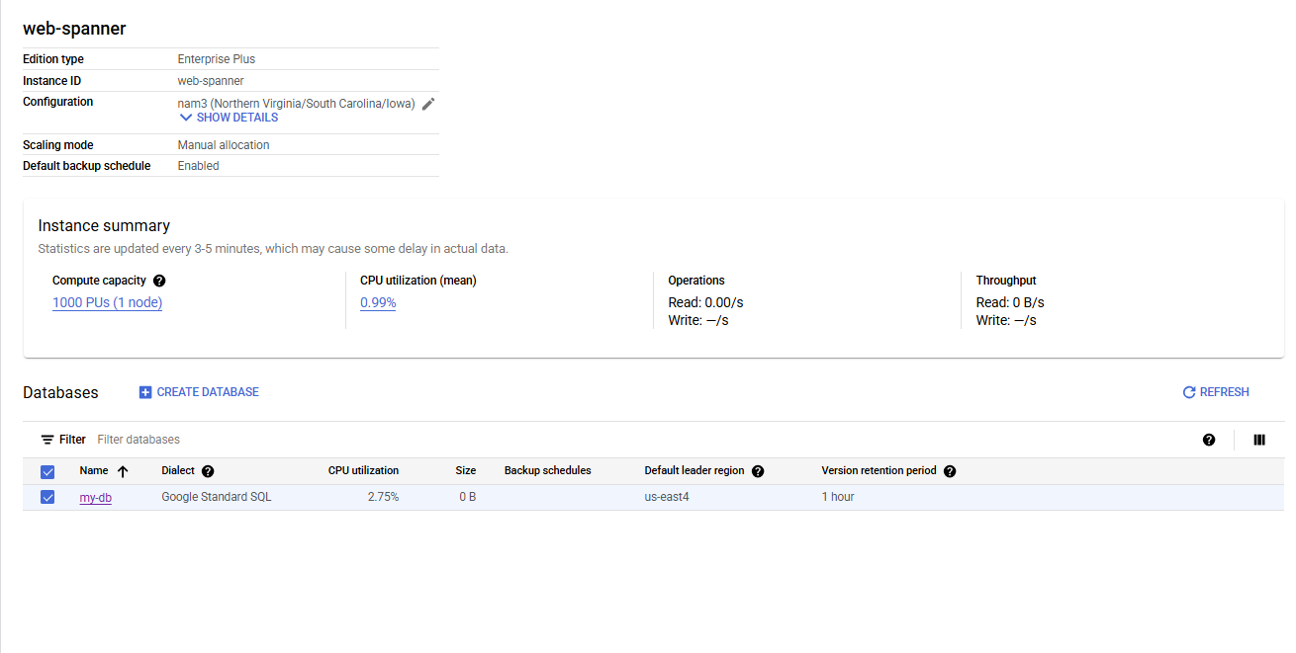

**Task 4 -** **Use Cloud CDN for low-latency delivery**

**Install a Web Server**

* + SSH into the VM → Run:

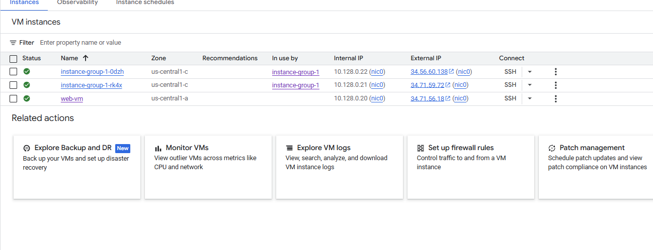

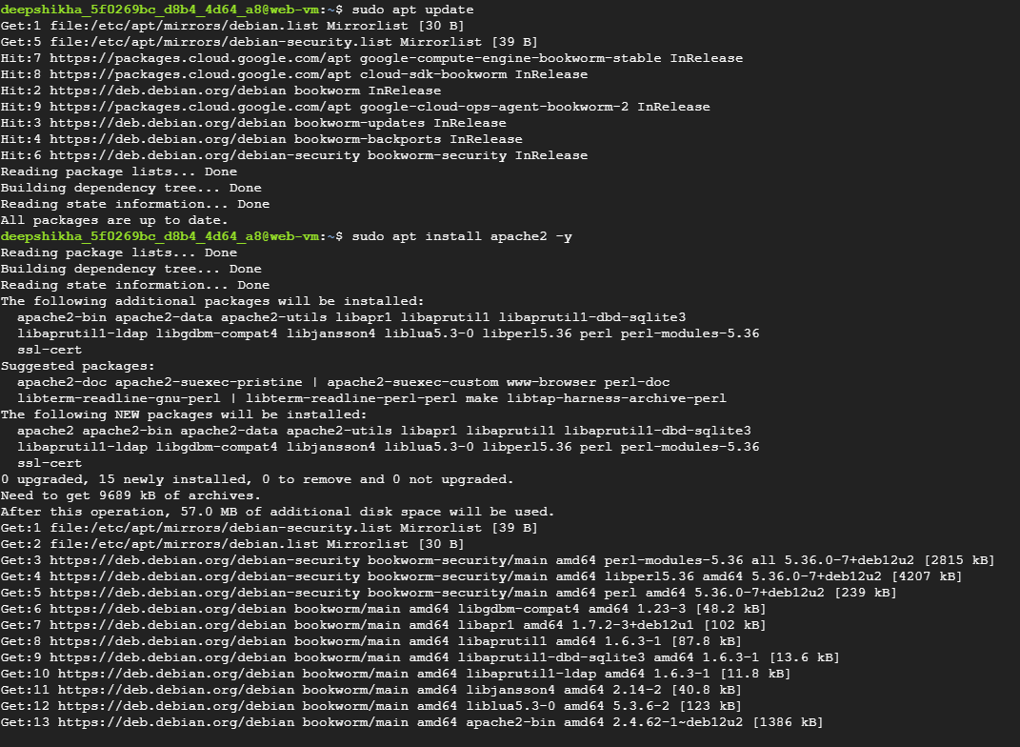

Output



Test the CDN



**Task 5 - Simulate extreme loads using Google Cloud Performance Testing Tools**

Option 1: Using Cloud Shell + Locust

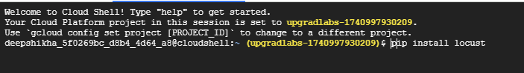

Create locustfile.py

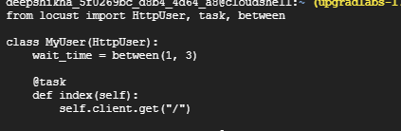

locust -f locustfile.py --host=http:// 34.128.156.44:80



Open URL given in Cloud Shell (usually port 8089)

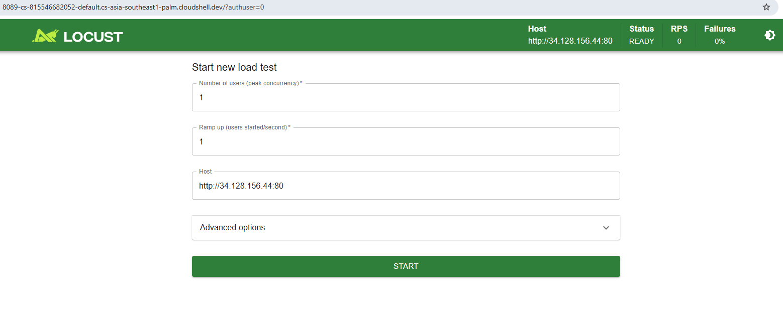

Start test with 10–100 users and monitor results

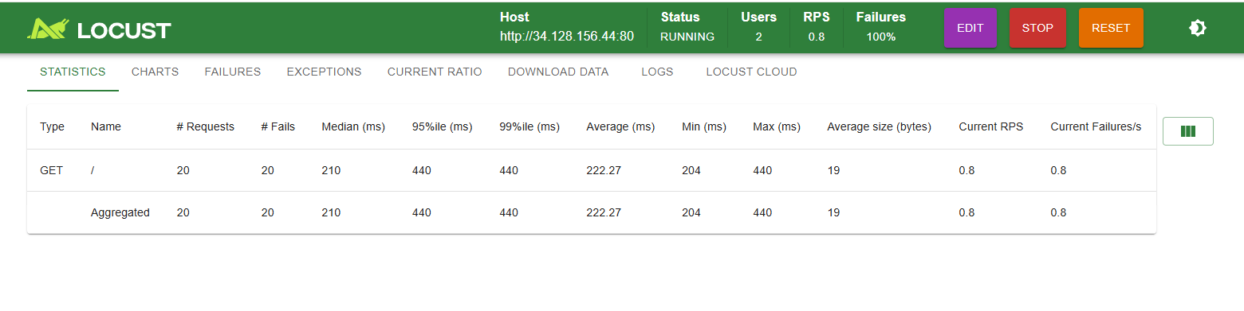

**Task 6 - Evaluate performance metrics and adjust scaling parameters**

Go to Monitoring Dashboard

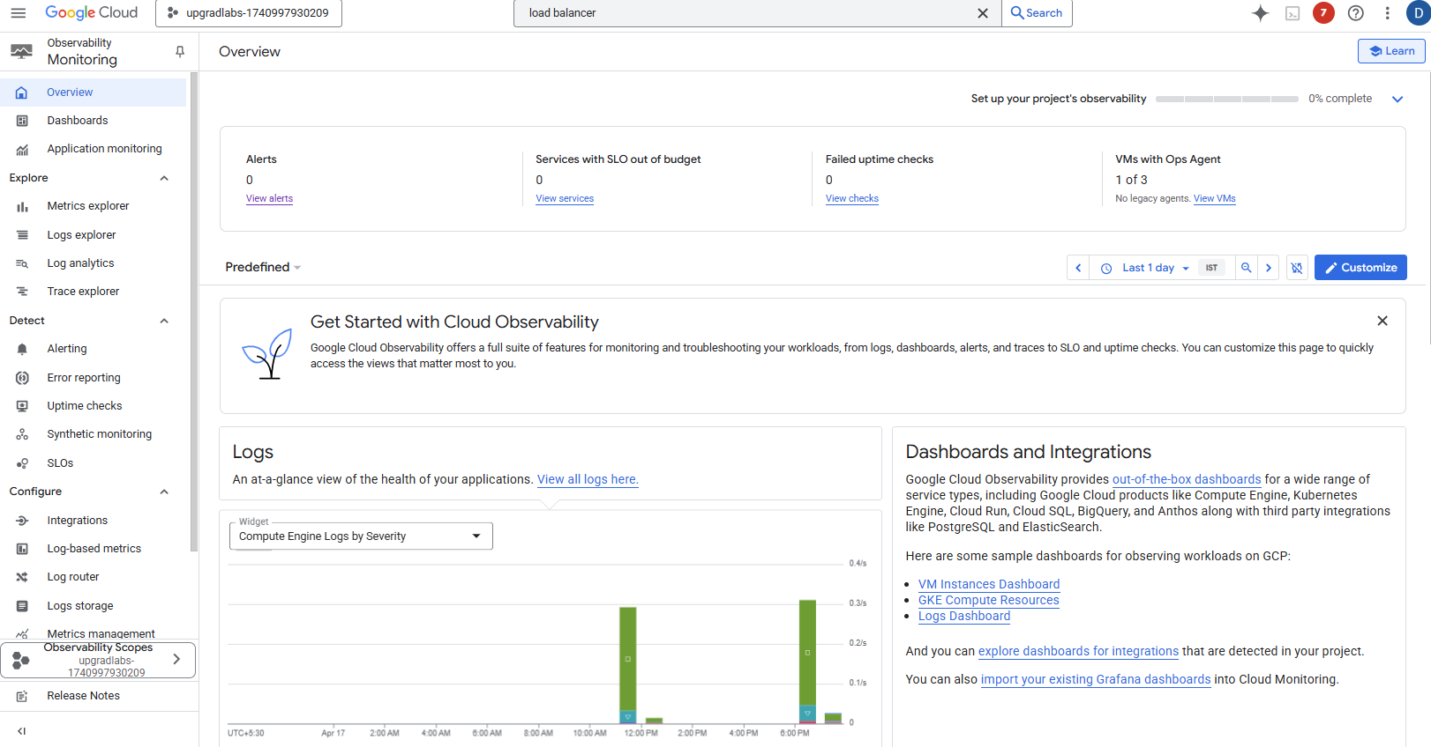

Create a Custom Dashboard

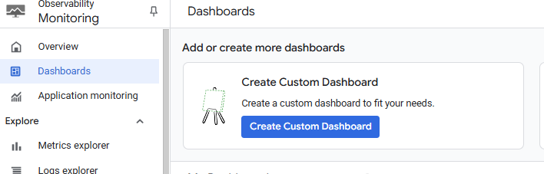

Select line option

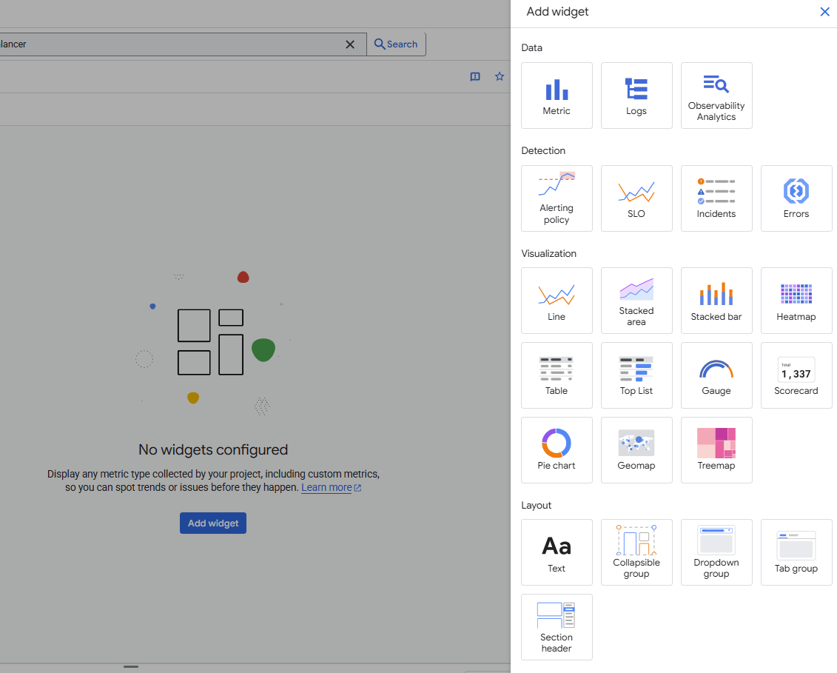

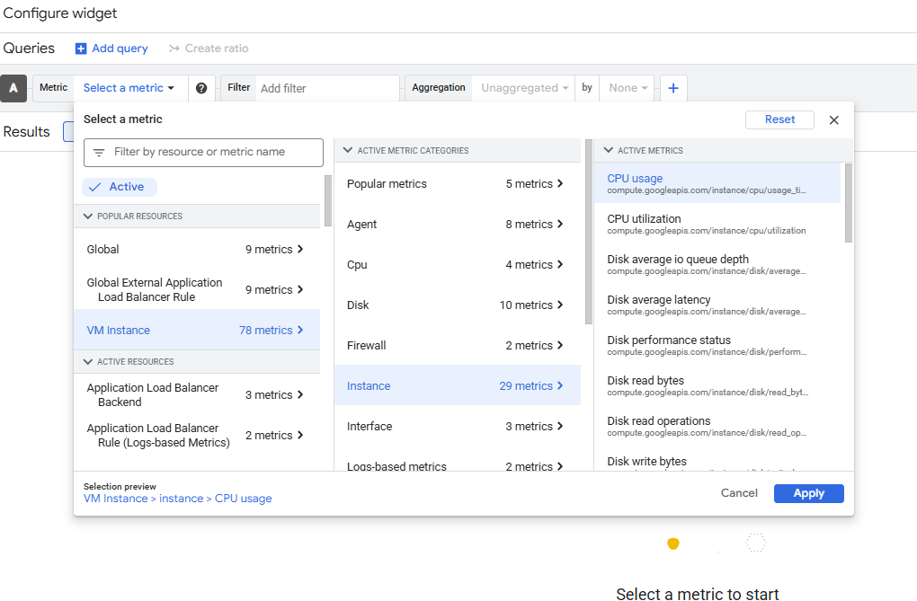

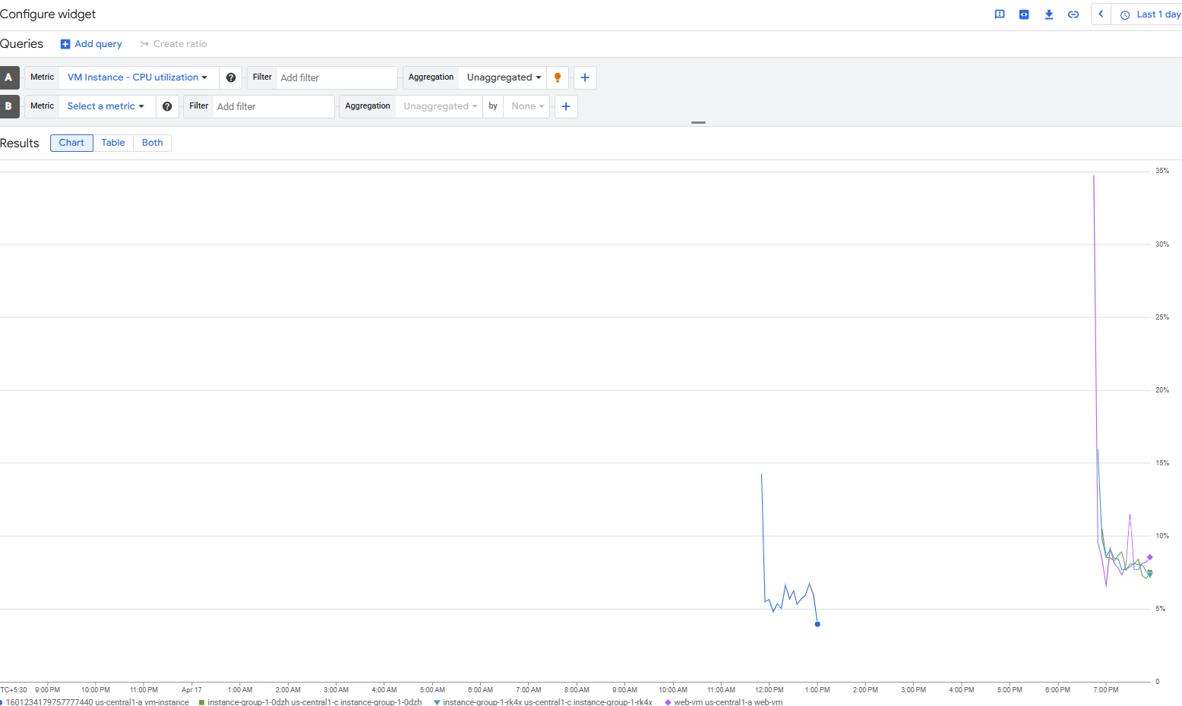

Create alert policy

